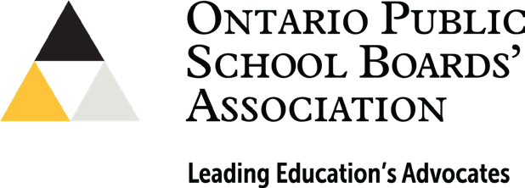
Local Government Week October 16-20, 2023

What are School Boards?

School board trustees are the oldest form of elected representation in Ontario. The office has been in existence since 1807 and represents citizens in the education decision-making process. School trustees are of the community, by the community, and for the community. They are members of the district school board and are the representatives of the public, and are the community’s advocates for public education.

Most trustees are elected every four years at the same time as municipal council elections. Many boards now also include the important voice of an Indigenous school board trustee from a First Nation located within the boundaries of the board. Student trustees are secondary students elected by their peers to represent the voice of students at the board table and there are also Hospital Board Trustees that are appointed by the Minister of Education.

How do School Board Trustees Support Students and Parents/Guardians?

Trustees establish the board vision, develop policies, allocate resources, and set the goals that lay the foundation driving programs and operations in the board. Collectively, they create a multi-year strategic plan for student achievement and well-being and recruit and monitor the performance of the Director of Education to ensure goals are met.

Here at the YOUR BOARD NAME HERE, are some of our priorities for the 2023-24 year:

LIST 3-5 PRIORITIES or LOCAL ISSUES HERE

The X Board
Customize this section for your local board. You could include facts and figures, the board logo, where the head office is, what departments exist and are located there, the board website, board advisory committees, including PIC, SEAC, Indigenous Education, etc., highlighting a key program, etc.

Please Contact Me:
NAME HERE
EMAIL AND/OR PHONE NUMBER HERE

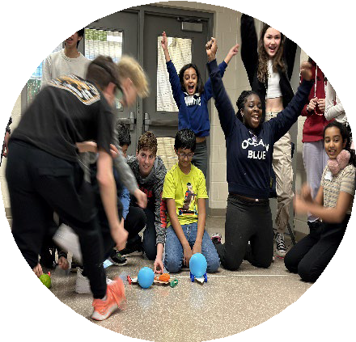

www.opsba.org

The Ontario Public School Boards’ Association represents English public district school boards and public school authorities across Ontario, which
together serve more than 1.3 million public elementary and secondary students. The Association advocates on behalf of the best interests and needs of the English public school system in Ontario.

