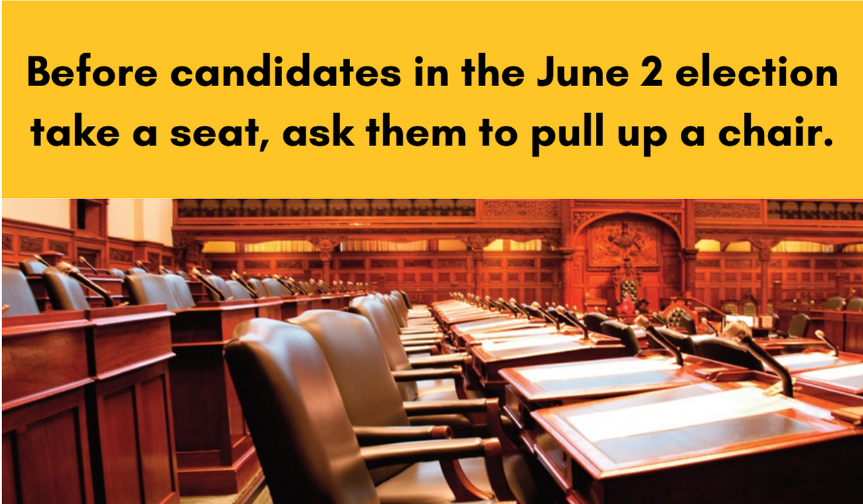
Government policies affect the world our children and youth will inherit tomorrow and their opportunities to get a good education today. The Provincial  government decides what is taught in our schools and how and where our Provincial taxes are used to pay for education. The future growth of the province depends on high quality, publicly-funded education. This impacts you whether or not you have children in the school system.  The results of the upcoming Provincial election are far-reaching. As a voter and citizen of Ontario it is in your interest to know where the candidates stand on the issues. So get involved. | Education Day is a non-partisan event where local candidates from the four major Provincial parties share their views and answer questions on the issues affecting public education.  For more resources related to OPSBA’s Education Day visit www.opsba.org.  Education Day is coordinated by local  public school trustees and the Ontario Public School Boards’ Association.  Follow the conversation on Twitter: #OntEd22 | Riding: Riding Name  Candidates: Candidate Name  Party Name  Candidate Name  Party Name  Candidate Name  Party Name  Candidate Name  Party Name  Moderator: Moderator Name  Title  Company Name  Location: Location Name  Location Address  Time: Day, Date  at Time
MAY 18, 2022: EDUCATION DAY
Before you mark your X, know your candidates’ ABCs

