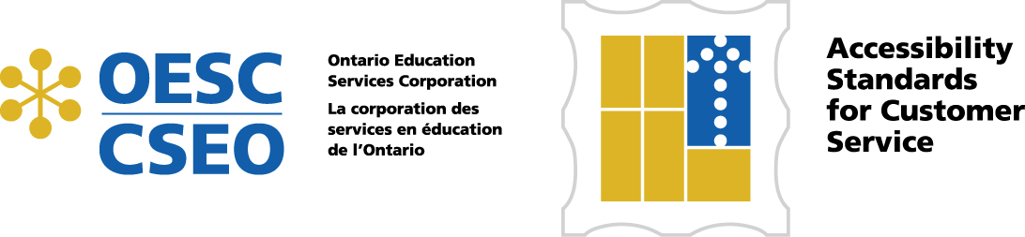

Accessibility Standards
for Customer Service

Policy Exemplar

Rationale
The XXXX District School Board is committed to providing services to our students, parents/guardians, the public and our staff that are free of barriers and biases. The XXX District School Board strives to ensure that key principles of independence, dignity, integration and equality of opportunity are reflected and valued in our learning and working environments. Our conduct will demonstrate our belief in the strength diversity brings to our communities.

Policy Statement
It is the policy of the XXXX District School Board to provide an environment in all of its facilities that builds independence, dignity and respect for our students, parents/guardians, the public and our staff. Further, we are committed to giving people with disabilities the same opportunity of access to our services in the same location and in a similar way as these services are available to all others we serve.

Definitions
Customer is any person who uses the services of the school board.
Assistive Device is any device used by people with disabilities to help with daily living. Assistive devices include a range of products such as wheelchairs, walkers, white canes, oxygen tanks, electronic communication devices.
Service Animal is an animal that is being used because of a person’s disability and this is either readily apparent or is supported by a letter from a medical practitioner.
Support Person is a person who assists or interprets for a person with a disability as they access the services of the Board. A support person is distinct from an employee who supports a student in the system.
Third Party Contractors is any person or organization acting on behalf of or as an agent of the Board (e.g. bus operators, psychologists).
Barriers to Accessibility means anything that prevents a person with a disability from fully participating in all aspects of the services of the Board. This includes, but is not limited to, a physical barrier, an architectural barrier, information or communications barrier, an attitudinal barrier, a technological barrier.
Accommodation is a means, through reasonable efforts, of preventing and removing barriers that impede individuals with disabilities from participating fully in the services of the Board.

Policy Exemplar Accessibility Standards for Customer Service 2

Board Expectations
- The Board will make all reasonable efforts to ensure that all policies, practices and procedures from the date of this policy forward are consistent with the principles of independence, dignity, integration and equality of opportunity to all with particular attention for persons with disabilities.
- The Board will welcome all members of the school and broader community to our facilities by committing our staff and volunteers to providing services that respect the independence and dignity of persons with disabilities, such service to incorporate measures that include but are not limited to the use of assistive devices and service animals.
- To ensure greater awareness and responsiveness to the needs of a person with disabilities, the Board will provide appropriate training for all staff who deal with the public or other third parties on behalf of the Board.
- Training as identified in No. 3 will be provided to all staff and, when appropriate, to volunteers. As new staff are hired, the training will become a component of their orientation training and will be provided within a reasonable timeframe.
- The Board will ensure that its policies and procedures related to the Accessibility for Ontarians with Disabilities Act, 2005 are made available to the public and also ensure there is capacity to provide communication about these policies and procedures in a format that takes into account a person’s disability.
- When services that are normally provided to a person with a disability are temporarily unavailable such as access to an elevator, a disruption of service notice will be posted at the site and on the Board’s website.
- In order to monitor the effectiveness of implementation of the Accessible Customer Service Standard, the Board will develop a process for receiving and responding to feedback. Information about the feedback process will be readily available to the public and will allow people to provide feedback using a number of methods.
- So that adherence to this policy can be achieved efficiently and effectively, the Board and all its managers and school-based administrators will take into account the impact on persons with disabilities when purchasing new equipment, designing new systems or planning a new initiative.
- The Board will create a feedback process that will review the implementation of this policy with the Board’s various constituency groups. Examples include Special Education Advisory Council (SEAC), Federations, unions, citizens’ groups and methods would include use of electronic means such as websites.
- The Board will also establish a process for consulting with frontline staff and volunteers who have a role in implementing the expectations and procedures established under this policy to review its effectiveness.

Policy Exemplar Accessibility Standards for Customer Service 3

Legal Framework
Accessibility for Ontarians with Disabilities Act, 2005 (AODA)
Accessibility Standards for Customer Service, Ontario Regulation 429/07
Ontario Human Rights Code

Cross-Referencing
Boards should use the appropriate mechanism to refer to other related Board Policies or procedures such as:
Board Accessibility Plan
Equity Policies
Procedures developed to address items from this policy.

